**Exposure time automation tool**

**Main Execution Manager**: Iliya Shir

**Project Owner**: Eli Sobolev

**Project Manager**: Eli Sobolev

**Author/Engineer**: Dennis Komarov

**Source: https://github.com/311725154/automated_exposure_snap.git**

**System requirements:**

1. **Operation system:** Windows 10/11 pack101.1 and later.
2. Python 3.9 and later
3. Installed modules:
   1. pyAutoGui – should be installed separately via pip.
   2. sys – *regular package already included*
   3. time – *regular package already included*

**Specification:**

|  |  |  |
| --- | --- | --- |
| **Source:** | **Specifications:** | **imports** |
| Autoexposure.py (exposure time, destination folder, file name, number) | The execution of the script is performed by the command line via MATLAB remote execution. The script runs while the “NITVision” application is already running, the script adjusts the exposure time in microseconds, according to the argument It gets from the command line call, then the script moves to the “recording” tab, sets the path of the destination folder, file name, and additional number index and finally hits the snap button. | Pyautogui  Time  sys |
| Autosnap.py ( repeats ) | The execution of the script is performed by the command line via MATLAB remote execution. The script moves to the “recording” tab and hits the snap button as many times as defined in the “repeats” argument. | Pyautogui  Time  sys |

|  |  |
| --- | --- |
| autoexposure(exposure_time, dest_folder, file_name, num) | function gets the parameters and using pyautogui module automates snap procedure :param exposure_time: int - exposure time in us :param dest_folder: string - save destination path :param file_name: string - file name :param num: int - additional elemen to file name for counting and indexing the output files :return: void |
| autosnap(rep) | perform auto snap o running state via pyautogui module :param rep: int - the number of repetitions needed for execution :return: void |

Both python code files must locate inside the directory with the snapshot files (.png),

If the user wants to separate the code files from its snapshot library, the path of the snapshot library must be included inside the code of each python file thus the variable should be updated:

local_folder_path = snapshot library path

The automation module uses the “pyAutoGui” library (<https://pyautogui.readthedocs.io/en/latest/>)

That performs a sequence of preprepared actions via force control of the keyboard and the mouse during the running, therefore **after lunching the module avoid moving the mouse or typing on the keyboard.**

Primary action sequence:

**Exceptions:**

The module throws exceptions of Operation system primary errors: while the searching process failed due to capturing extraction, detecting, or quality failure.

Any of the exceptions care by continuing to the next step execution.

**Complexity:**

No special treatment to algorithm complexity was granted, thus all subprocess runs at least in linear complexity and less than O(n2) complexity. **There were no special algorithms implemented.**

**Algorithms:**

***Sutoexposure.py:***

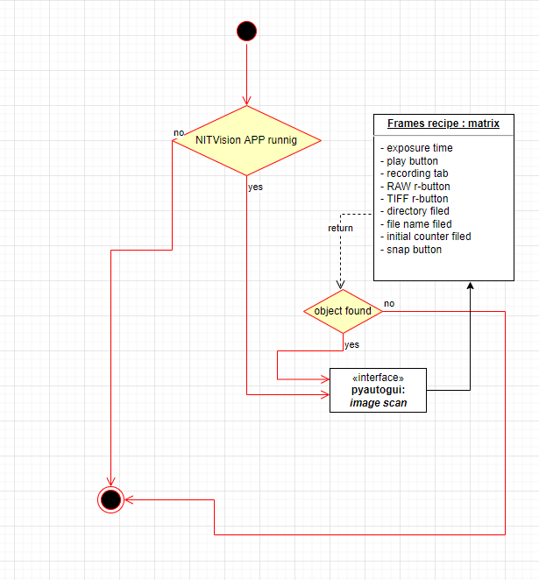

**autosnap.py:**

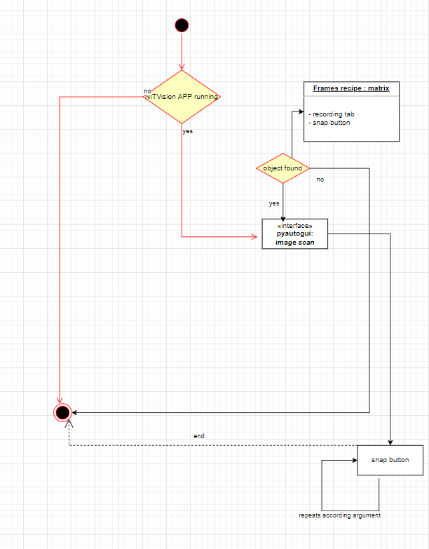

**Execution:**

from command line:

python <script name>.py argument1 argoment2 …



Actual design based on implementation into MATLAB execution trigger